LESSON A-1: THE CPU
TOPIC
A1
AND GPU [34]
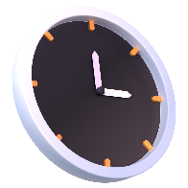
TIME TO COMPLETE: 1 HOUR
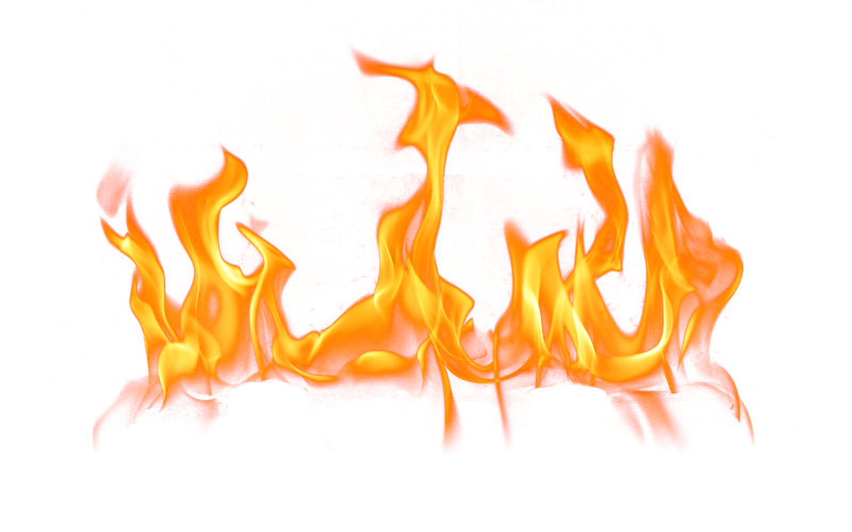

WARM UP:
WHAT YOU’LL NEED: PyCharm · a browser · the CPU diagram from Lesson A1-1
Q1. From the CPU diagram we built last lesson:
(a) Which register holds the address of the next instruction to be fetched? [1]

(b) Which register holds the instruction currently being executed? [1]

(c) Which bus carries an address from the CPU to memory, and is it one-way or two-way? [1]

PRIMARY MEMORY
Q2. Complete the table. [4]
Memory type | What it is for (one line) | Volatile? Y / N | Speed rank (1 = fastest)
Registers
Cache
RAM
ROM
Q3. Cache is built in levels: L1, L2 and L3. State two ways in which L1 differs from L3. [2]
1.
2.

CACHE HITS AND MISSES [5 marks]
Q4. (a) Define cache hit. [1]

(b) Define cache miss. [1]

(c) A CPU has a cache hit rate of 90%. A cache access takes 1 ns; a miss must go out to RAM and takes 100 ns. Calculate the average memory access time. Show your work. [2]

(d) The hit rate now drops to 50%. Calculate the new average access time. [1]

THE FETCH, DECODE, EXECUTE CYCLE [9 marks]
Q5. Fill in the blanks as we work through the cycle. Two blanks = 1 mark. [5]
FETCH 1. The address of the next instruction is copied from the __________ into the __________.
2. The MAR puts that address onto the __________ bus.
3. The control unit sends a __________ signal along the control bus.
4. The instruction travels back along the __________ bus and lands in the _________.
5. The instruction is then copied into the __________.
6. The PC is ________ so that it points at the next instruction.
DECODE 7. The __________ interprets the opcode held in the IR.
EXECUTE 8. The __________ performs the operation, and the result is placed in the __________.
Q6. Here’s the program you will type into LMC. Complete one row of the trace table per cycle. [4]
In memory: 0: LDA 4 1: ADD 5 2: STA 6 3: HLT address 4 holds 12, address 5 holds 30, address 6 holds 0

Cycle | PC after fetch | IR | AC after execute | Memory changed?
1
2
3
4

PIPELINING [HL ONLY] [3 marks]
Q7. (a) Name the four pipeline stages. [1]

(b) Explain how pipelining lets a processor complete more instructions per second without running at a higher clock speed. [2]

LAB [8 marks]
Q8. Describe the role of the memory data register (MDR) during the fetch stage. [2]

Q9. Explain why a cache miss slows the CPU down, with reference to the memory hierarchy. [3]

Q10. Explain how the address, data and control buses interact during the fetch stage of the cycle. [3]

